

Treasury Eco System_ Data Flows

Version 1.0

Table of Contents

Document history: 4

1 Introduction 5

1.1 Purpose 5

2 Data Flow Diagrams 6

2.1 Treasury Eco System- File-Based Data Flows: Market Data 6

2.2 Treasury Eco System – File-based Data Flows : Analysis and Reporting 7

2.3 Treasury Eco System – File-based Data Flows : Analysis and Reporting 8

2.4 Treasury Eco System – File-based Data Flows : Limits 9

9

2.5 Treasury Eco System –File-based Data Flows : Projected Cashflows, Nostro Position and FX Position 10

2.6 Treasury Eco System – File-based Data Flows : Customers and Users 11

2.7 Treasury Eco System – File-based Data Flows : OMS/EMS Trades 12

2.8 Treasury Eco system – Real Time/Near Real Time Data Flows 13

2.9 Treasury Eco System – Data Flows :Core Banking Transaction with FX Preferential Rate From FX Sales Trader [Book=MCB.Fx.Sales.External] 14

2.10 Treasury Eco System – Data Flows :Export and Import of FCY Notes - Preferential rate from FX Trader [Book= MCB.FX.Flow.External] 15

# Document history:

|  |  |  |  |  |
| --- | --- | --- | --- | --- |
| **Revision Date** | **Version** | **Revision Description** | **Amended by** | **Reviewed by** |
| 24/06/2020 | 1.0 | Source version 2019-04-16 17H :   1. Amend sheet   from  Treasury Eco System – Data Flows : Core Banking Transaction with FX Preferential Rate  To  Treasury Eco System – Data Flows : Core Banking Transaction with FX Preferential Rate From FX Sales Trader [Book=MCB.Fx.Sales.External] | Louise Lock Son | WIP |
|  |  | 1. Add new sheet   Treasury Eco System – Data Flows :  Export and Import of FCY Notes - Preferential rate from FX Trader [Book= MCB.FX.Flow.External] | Louise Lock Son | Arnaud Esther |
|  |  | 1. Add new sheet   Treasury Eco System – File-based Data Flows : Projected Cashflows, Nostro Position and FX Position | Louise Lock Son | Arnaud Esther/  Hanley Moothen |
|  |  | 1. Added MT messages – incoming and outgoing that Calypso processes as advised by business in sheet   Treasury Eco system – Real Time/Near Real Time Data Flows | Louise Lock Son |  |

# Introduction

## Purpose

The purpose of this document is to provide the data flows for the Treasury Eco System.

# Data Flow Diagrams

## Treasury Eco System- File-Based Data Flows: Market Data

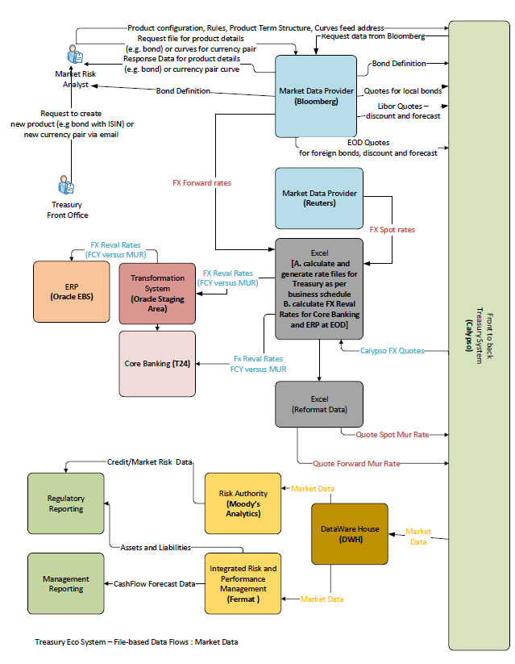

## Treasury Eco System – File-based Data Flows : Analysis and Reporting

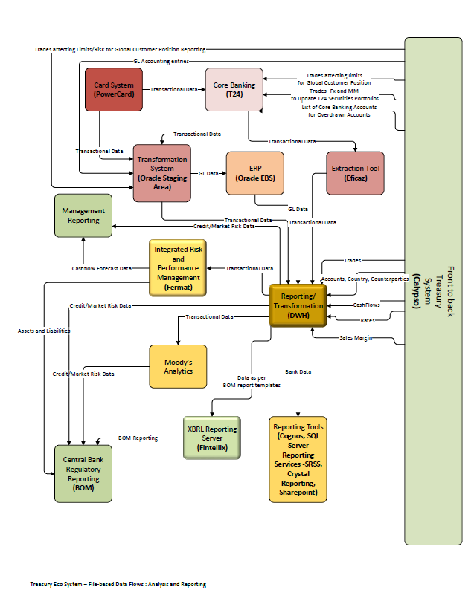

## Treasury Eco System – File-based Data Flows : Analysis and Reporting

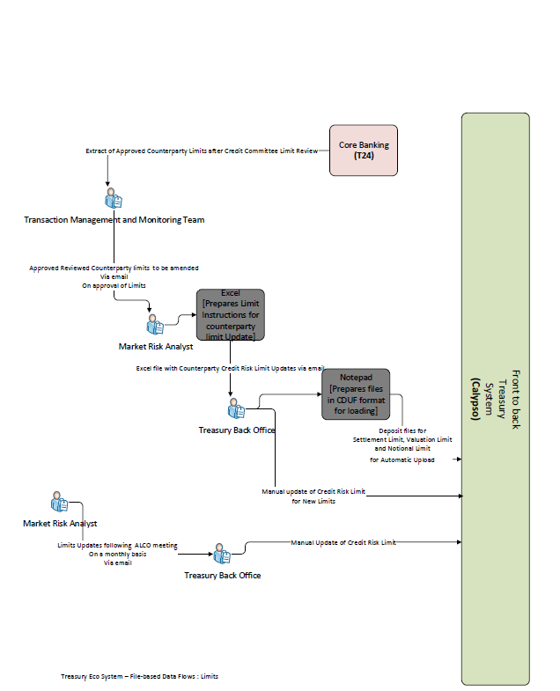

## Treasury Eco System – File-based Data Flows : Limits

## 

## Treasury Eco System –File-based Data Flows : Projected Cashflows, Nostro Position and FX Position

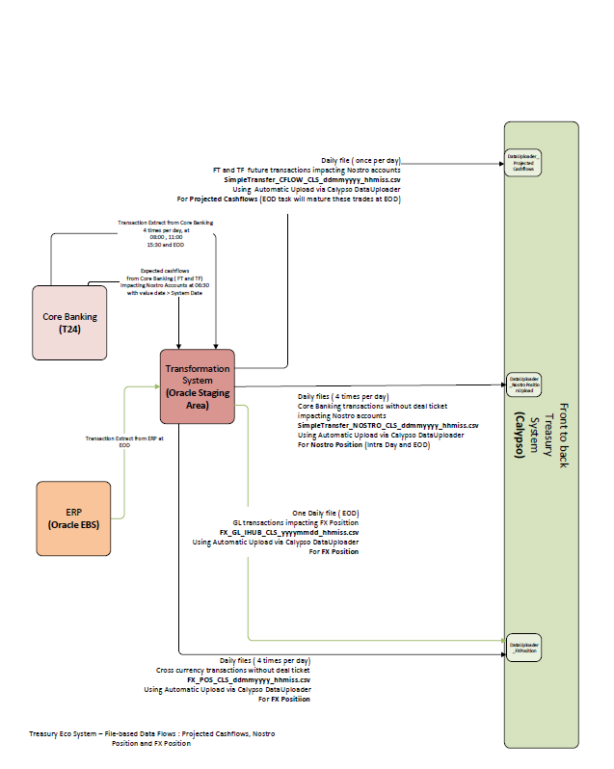

## Treasury Eco System – File-based Data Flows : Customers and Users

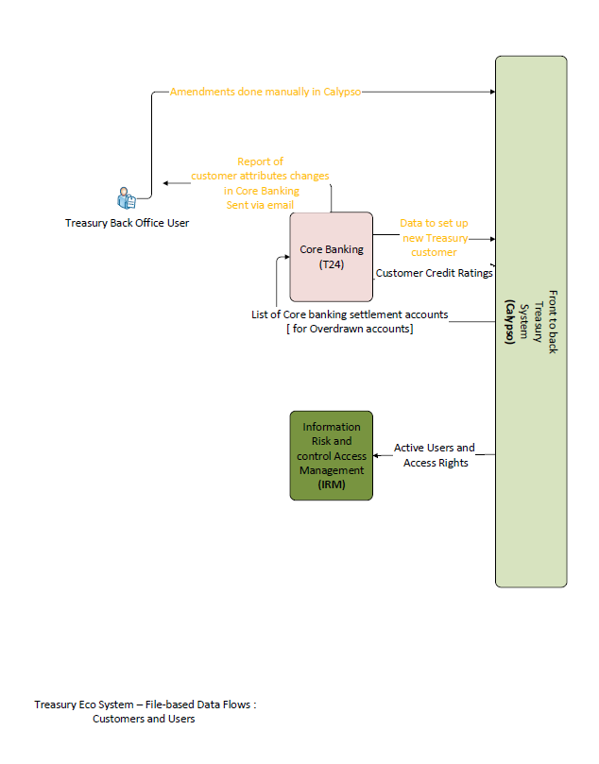

## Treasury Eco System – File-based Data Flows : OMS/EMS Trades

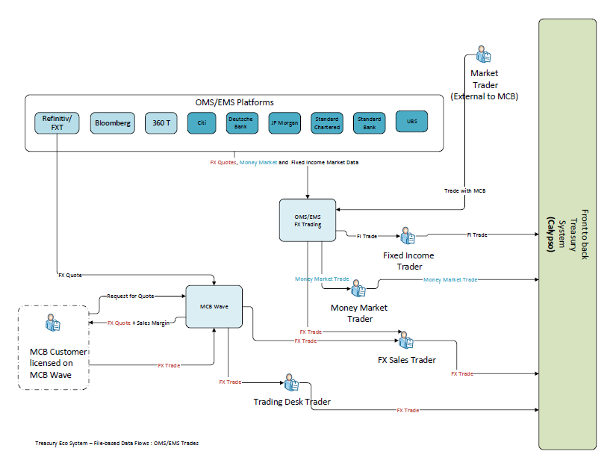

## Treasury Eco system – Real Time/Near Real Time Data Flows

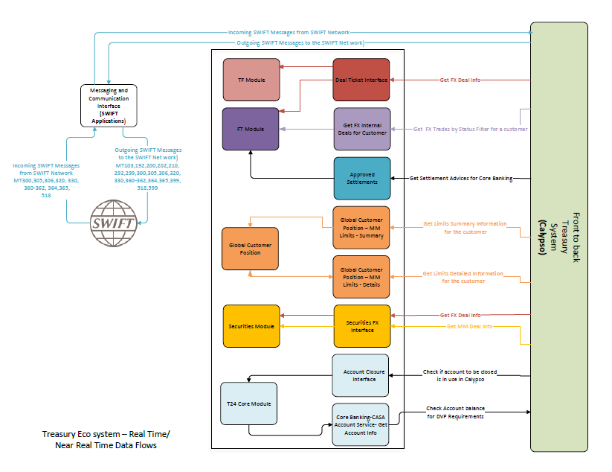

## Treasury Eco System – Data Flows :Core Banking Transaction with FX Preferential Rate From FX Sales Trader [Book=MCB.Fx.Sales.External]

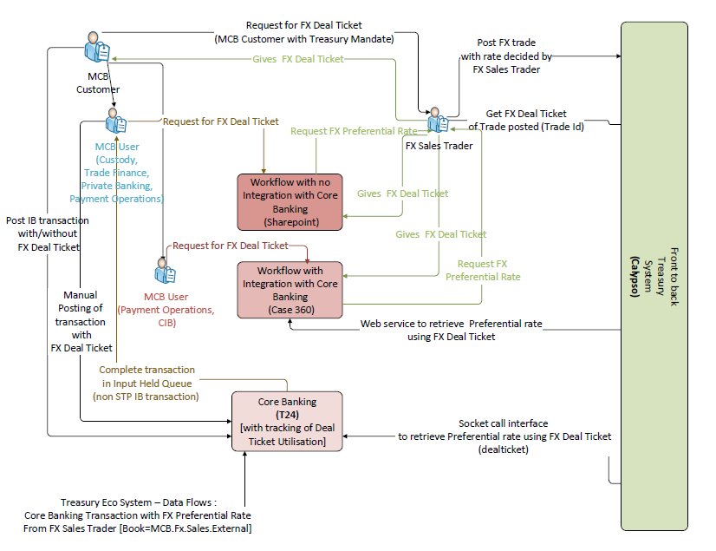

## Treasury Eco System – Data Flows :Export and Import of FCY Notes - Preferential rate from FX Trader [Book= MCB.FX.Flow.External]

